Name of Student : Raghav Mahesh Sarda PRN: 25070122235
Subject: Programming with Java Semester: III
ASSIGNMENT No : 13 Year: AY 2026-27
TITLE : File Handling in Java

Problem Statement
Write a Java program to perform reading from and writing to a file using file handling operations.

Learning Objectives
To perform file reading and writing operations using Java file handling classes.

Program:
FileReadWrite.java
// Assignment 13 - Exercise 1: Writing and Reading text using FileWriter and FileReader
import java.io.*;
import java.util.*;
public class FileReadWrite
{
public static void main(String args[])
{
Scanner sc = new Scanner(System.in);
System.out.print("Enter text to write into file: ");
String text = sc.nextLine(); // Reading text from user

try // Handling file exceptions
{
FileWriter fw = new FileWriter("output.txt"); // Creating FileWriter object
fw.write(text); // Writing string data into file
fw.close(); // Closing FileWriter
System.out.println("Data successfully written to file!");

FileReader fr = new FileReader("output.txt"); // Creating FileReader object
System.out.print("Reading content from file: "); // Header
int ch; // Variable to store character ASCII value
while((ch = fr.read()) != -1) // Reading characters until EOF (-1)
{
System.out.print((char)ch); // Displaying character
}
System.out.println(""); // Blank line
fr.close(); // Closing FileReader
}
catch(IOException e) // Catching I/O exceptions
{
System.out.println("File Error: " + e.getMessage()); // Error message
}

sc.close();
}
}

StudentRecord.java
// Assignment 13 - Exercise 2: Storing and Reading Student Records using Files
import java.io.*;
import java.util.*;
public class StudentRecord
{
public static void main(String args[])
{
Scanner sc = new Scanner(System.in);
System.out.print("Enter Student Roll No: ");
int roll = sc.nextInt();
sc.nextLine(); // Consuming newline
System.out.print("Enter Student Name: ");
String name = sc.nextLine();
System.out.print("Enter Student Branch: ");
String branch = sc.nextLine();

try
{
FileWriter writer = new FileWriter("students.txt"); // Opening file for writing
writer.write("Roll No: " + roll + "\nName: " + name + "\nBranch: " + branch + "\n"); // Writing details
writer.close(); // Closing stream
System.out.println("Student record stored successfully!");

File file = new File("students.txt"); // Creating File object
Scanner fileReader = new Scanner(file); // Scanner to read from file

System.out.println("\n--- Fetching Student Details from File ---"); // Section header
while(fileReader.hasNextLine()) // Iterating line-by-line
{
System.out.println(fileReader.nextLine());
}
fileReader.close(); // Closing file scanner
}
catch(IOException e)
{
System.out.println("An error occurred: " + e.getMessage()); // Error message
}
sc.close();
}
}

Output:
FileReadWrite.java
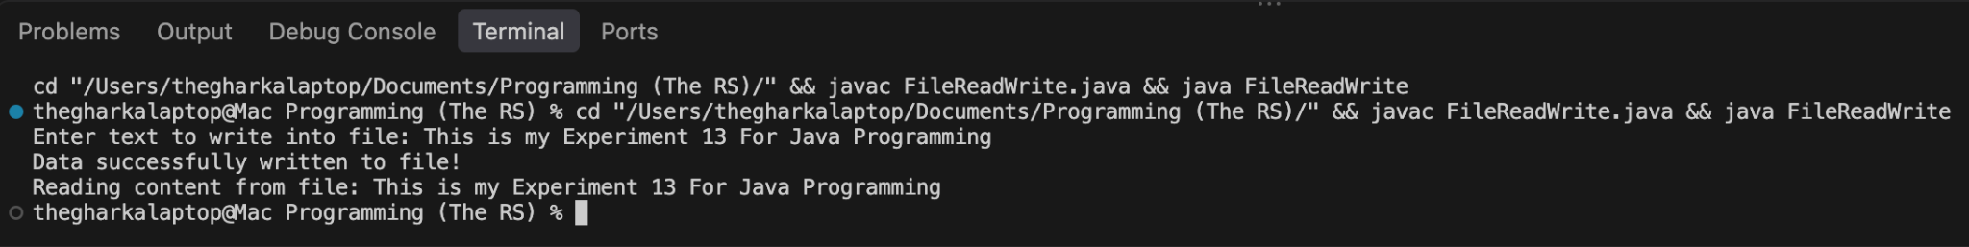
StudentRecord.java
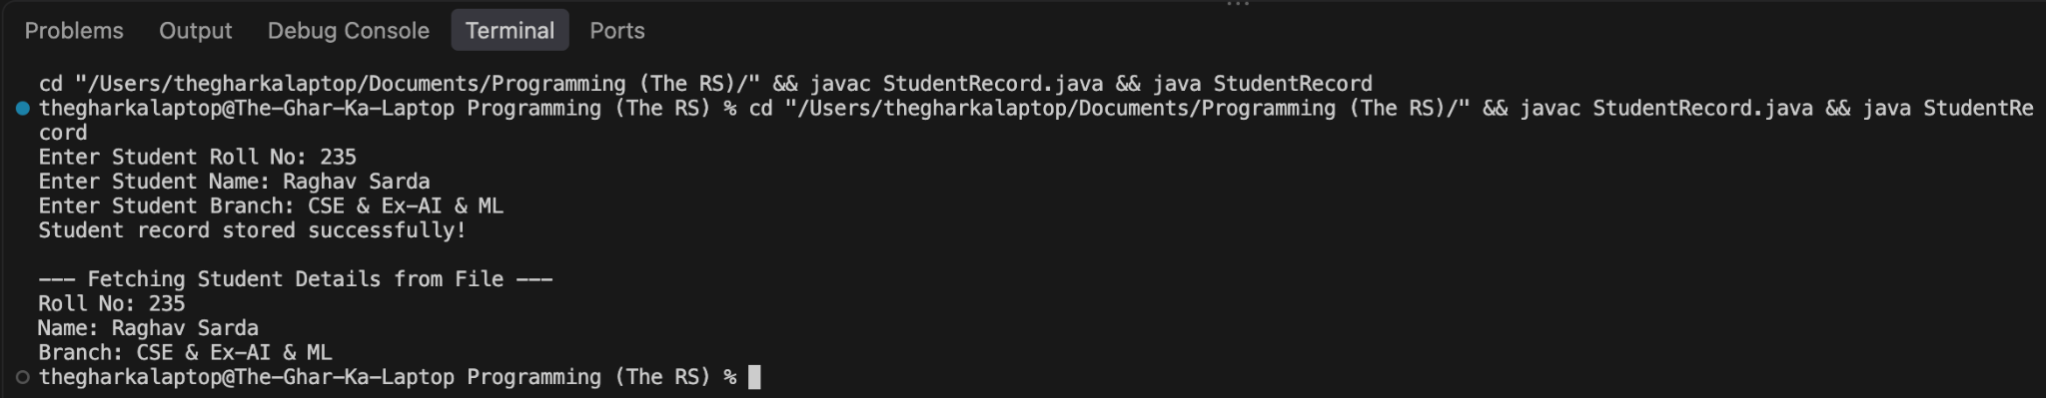
Conclusion:
In this assignment, the concepts of persistent data storage and byte-stream management using Java file handling classes were successfully implemented and verified. Writing operations allowed dynamic user data to be stored securely onto disk files using FileWriter, and reading operations enabled accurate data retrieval and sequential processing using FileReader and File Scanner streams without data loss.

